Bundle whitelisting – To get the resource resolver

**Problem Statement:**AEM has deprecated its Administrative Login but not removed completely. There are some bundles still available, who are using old Administrative login. So a whitelisting mechanism was introduced with [SLING-5153](https://issues.apache.org/jira/browse/SLING-5135) (*JCR Base 2.4.2*). If there a need to use Administrative Login, you can whitelist your bundle and use it either it is not recommended.

**If you use adminResourceResolver, the log file shows below error:**

|  |
| --- |
| 03.10.2017 23:43:26.858 *ERROR* [0:0:0:0:0:0:0:1 [1507054406856] GET /bin/slingModels HTTP/1.1] com.adobe.granite.repository.impl.SlingRepositoryImpl Bundle com.sling.models.Sling-Models.core is NOT whitelisted to use SlingRepository.loginAdministrative |

The other scenario can be that there is some older bundle you are using, so you can whitelist this bundle for Administrative Login to continue your work.

**How to whitelist a bundle?**

1. **Apache Sling Login Admin Whitelist**

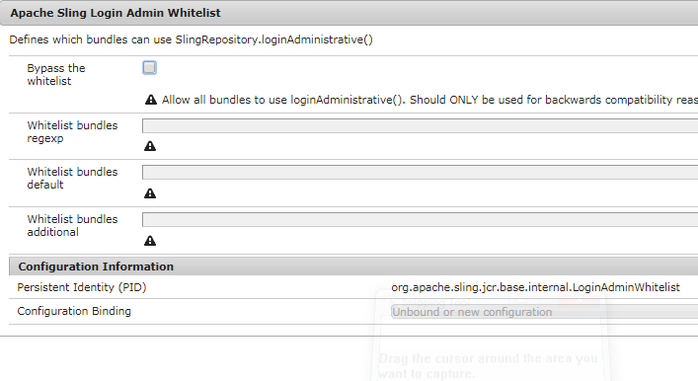

* **Bypass the whitelist**: If this configuration is true, by default all the bundles will be allowed to use adminResourceResolver. It is good option, when you are in a mid of work and don't want to choose the bundles, which are having adminResourceResolver. But it is not recommended in a production at all.
* All the other options are clear with the name only. Just need to add bundle symbolic name in a regex or simple format.

1. **Apache Sling Login Admin Whitelist Configuration Fragment**

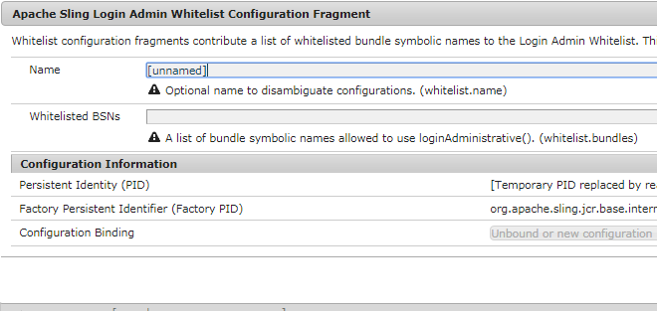

If you want to use project level configurations for bundle whitelisting, you can use this:

**Name**: Name of the bundle (Any Name) which you are adding in whitelist.

**Whitelisted BSNs**: The symbolic name of the bundle to be whitelisted.